Dear Prof. Jeannot Trampert:

We thank you and the reviewers for the insightful comments for our manuscript GJI-14-0858 entitled "Remotely triggered earthquakes in South-Central Tibet following the 2004 Mw 9.1 Sumatra and 2005 Mw 8.6 Nias earthquakes". We are hereby submitting a revised version that accounts for the comments. Below are the detailed responses to all the points. We marked the original comments as **bold**, our reply as regular font, and new text inserted/revised in the paper as *italic*.

We thank you and the reviewers again and hope that the revised version will be accepted for publication.

Best regards,

Dongdong Yao, Zhigang Peng and Xiaofeng Meng

**Reviewer: 1  
Comments to the Author(s)**

1. **I suggest changing page 1, lines 44-48, which note that “In most cases, triggered events occur during or immediately following the teleseismic surface waves”.  One should question the extent to which this perception is a result of observational bias.  We identify a causal connection more easily when two events are temporally close together; i.e. if a change in earthquake rate occurs long after some perturbing deformation we are less likely to say they are related.  In addition, one also wonders how many studies simply look only within the interval of the teleseismic wavetrain or immediately thereafter?  If a significant number of studies, one cannot draw the conclusion noted.**

Done. I change the sentence to “*Triggered events could occur during or immediately following the teleseismic surface waves due to the transient peak dynamic stress perturbation*”. Indeed, it’s easier to establish a causal connection for two events temporally close. We still cannot explain the delay time for delayed triggering since the mechanism is on debate.

1. **How did the authors determine that  “While many new local events were detected, 95% are aftershocks of the 2005 Zhongba mainshock”? (pg. 4, lines 30-31).**

We simply calculate the ratio between the number of events occur after the 2005 Zhongba mainshock and the total number of detection. Totally, we detect 6453 events in our study period (03/21/2005-04/14/2005). Among them, 6278 occurred after the 2005 Zhongba event and we consider them as its aftershocks. The two numbers result in a 95% ratio.

1. **It would be very interesting to learn whether any of the M>6 earthquakes in Zhongba earthquakes triggered activity in the Gaize region, and how the characteristics of the wavefields from those earthquakes as observed in the Gaize region compared with those of the teleseisms examined.**

It’s a very nice suggestion. We also did try to investigate whether the Zhongba sequences triggered event in the Gaize region. Based on Figure 5c in the main content, the 2005 Zhongba earthquake (2005/04/07 20:04:41.06) occurred 243.918 hours after the 2005 Nias mainshock. We didn’t find any seismicity rate change in Gaize around that time. The same XF network didn’t record the 2008 Zhongba earthquake, and we didn’t contain the 2004/07/11 Zhongba event in our study period.

1. **Maybe this has been addressed and I’ve missed it, but to what extent might the apparent difference in triggering in the Zhonga and Gaize regions be due to the difference in detection thresholds?  The thresholds for Zhonga are .6 and 1.0, and almost an order of magnitude lower for Gaize, -.8 and -.6.  If only events with M>.6 and 1.0 were used in Gaize, how much would the results change?**

We agree that this could be due to the different detection thresholds. However, the different epicentral distances contribute to the detection limits. The average epicentral distance in Zhongba is 150km while it’s only 50km in Gaize. In this way, we expect to see a higher Mc in Zhongba (updated values: 1.1 for detection around 2004 Sumatra and 1.7 around 2005 Nias) compared to Gaize (-0.6 and -0.4, respectively). We also follow the reviewer’s suggestion by selecting events with the same Mcs in Zhongba for detection in Gaize, and the results are shown in the following Figure 1. Clearly, they are consistent and have no obvious differences.

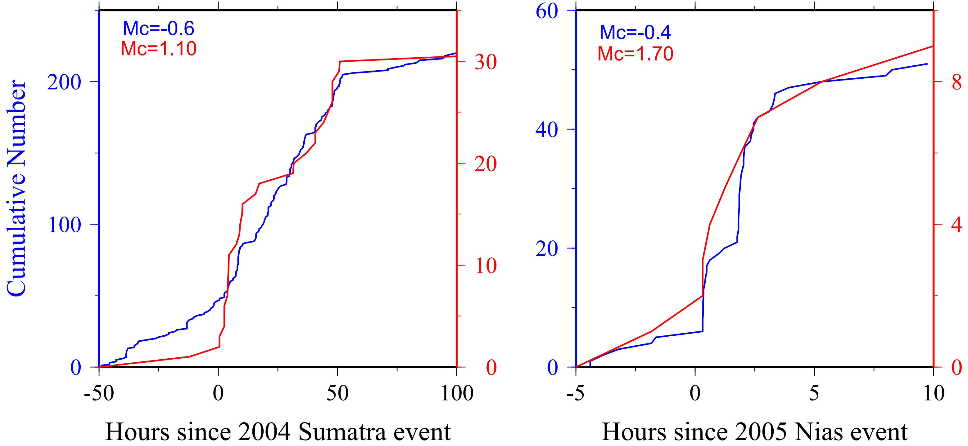

Figure 1. Comparisons for different Mcs

1. **Perhaps a test of the reason offered to explain why a dynamic stress shadow would exist  (lines 43-45, page 5) would be to look at how many events triggered by the Sumatra earthquake were potentially retriggered by the Nias earthquake.  If one assumed that it took longer than 3 months to reload a fault (the time between the Sumatra and Nias earthquakes) and the proposed explanation was true, one would expect that all the faults triggered by the Nias earthquake would be different than those triggered by the Sumatra earthquake.  One way to assess this would be to measure which templates triggered which earthquakes, i.e. did templates chosen from post-Sumatra seismicity match only those detected in the pre-Nias interval and templates from the post-Nias period only match post-Nias triggered events?  If an event from the post-Nias period matched a template from the post-Sumatra period, indicating it could be a re-rupture of the same fault, this would make questionable the assertion that the post-Sumatra quiescence reflected a using up of finite population of available ripe faults (unless again, they could reload within 3 months, which seems unlikely).**

We follow the reviewer’s suggestion and operate a simple test by matching the templates. The simplest way is to compare the locations of post-Sumatra and post-Nias templates, which is shown in Figure 2 below. Gray open circles are all templates using for detection, while green and blue ones are post-Sumatra (within 100 hours consistent with Figure 5b) and post-Nias (within 10 hours indicated by Figure 5d) templates, respectively. There’s no overlapping among them, and the 2005 Nias event triggered larger events close to where smaller events were triggered by 2004 Sumatra event. The largest triggered events by both events are separated from each other. Besides, we also check which templates triggered which earthquakes. The detected catalogs show the detection together with the most similar template (highest cross-correlation coefficient) and by looking into them could give us some hints. The result indicates that the detected post-Sumatra events match post-Sumatra and pre-Nias templates, while the detected post-Nias events match templates around the Nias event, which means no overlapping between post-Sumatra and post-Nias triggered earthquakes, as shown in Figure 3.

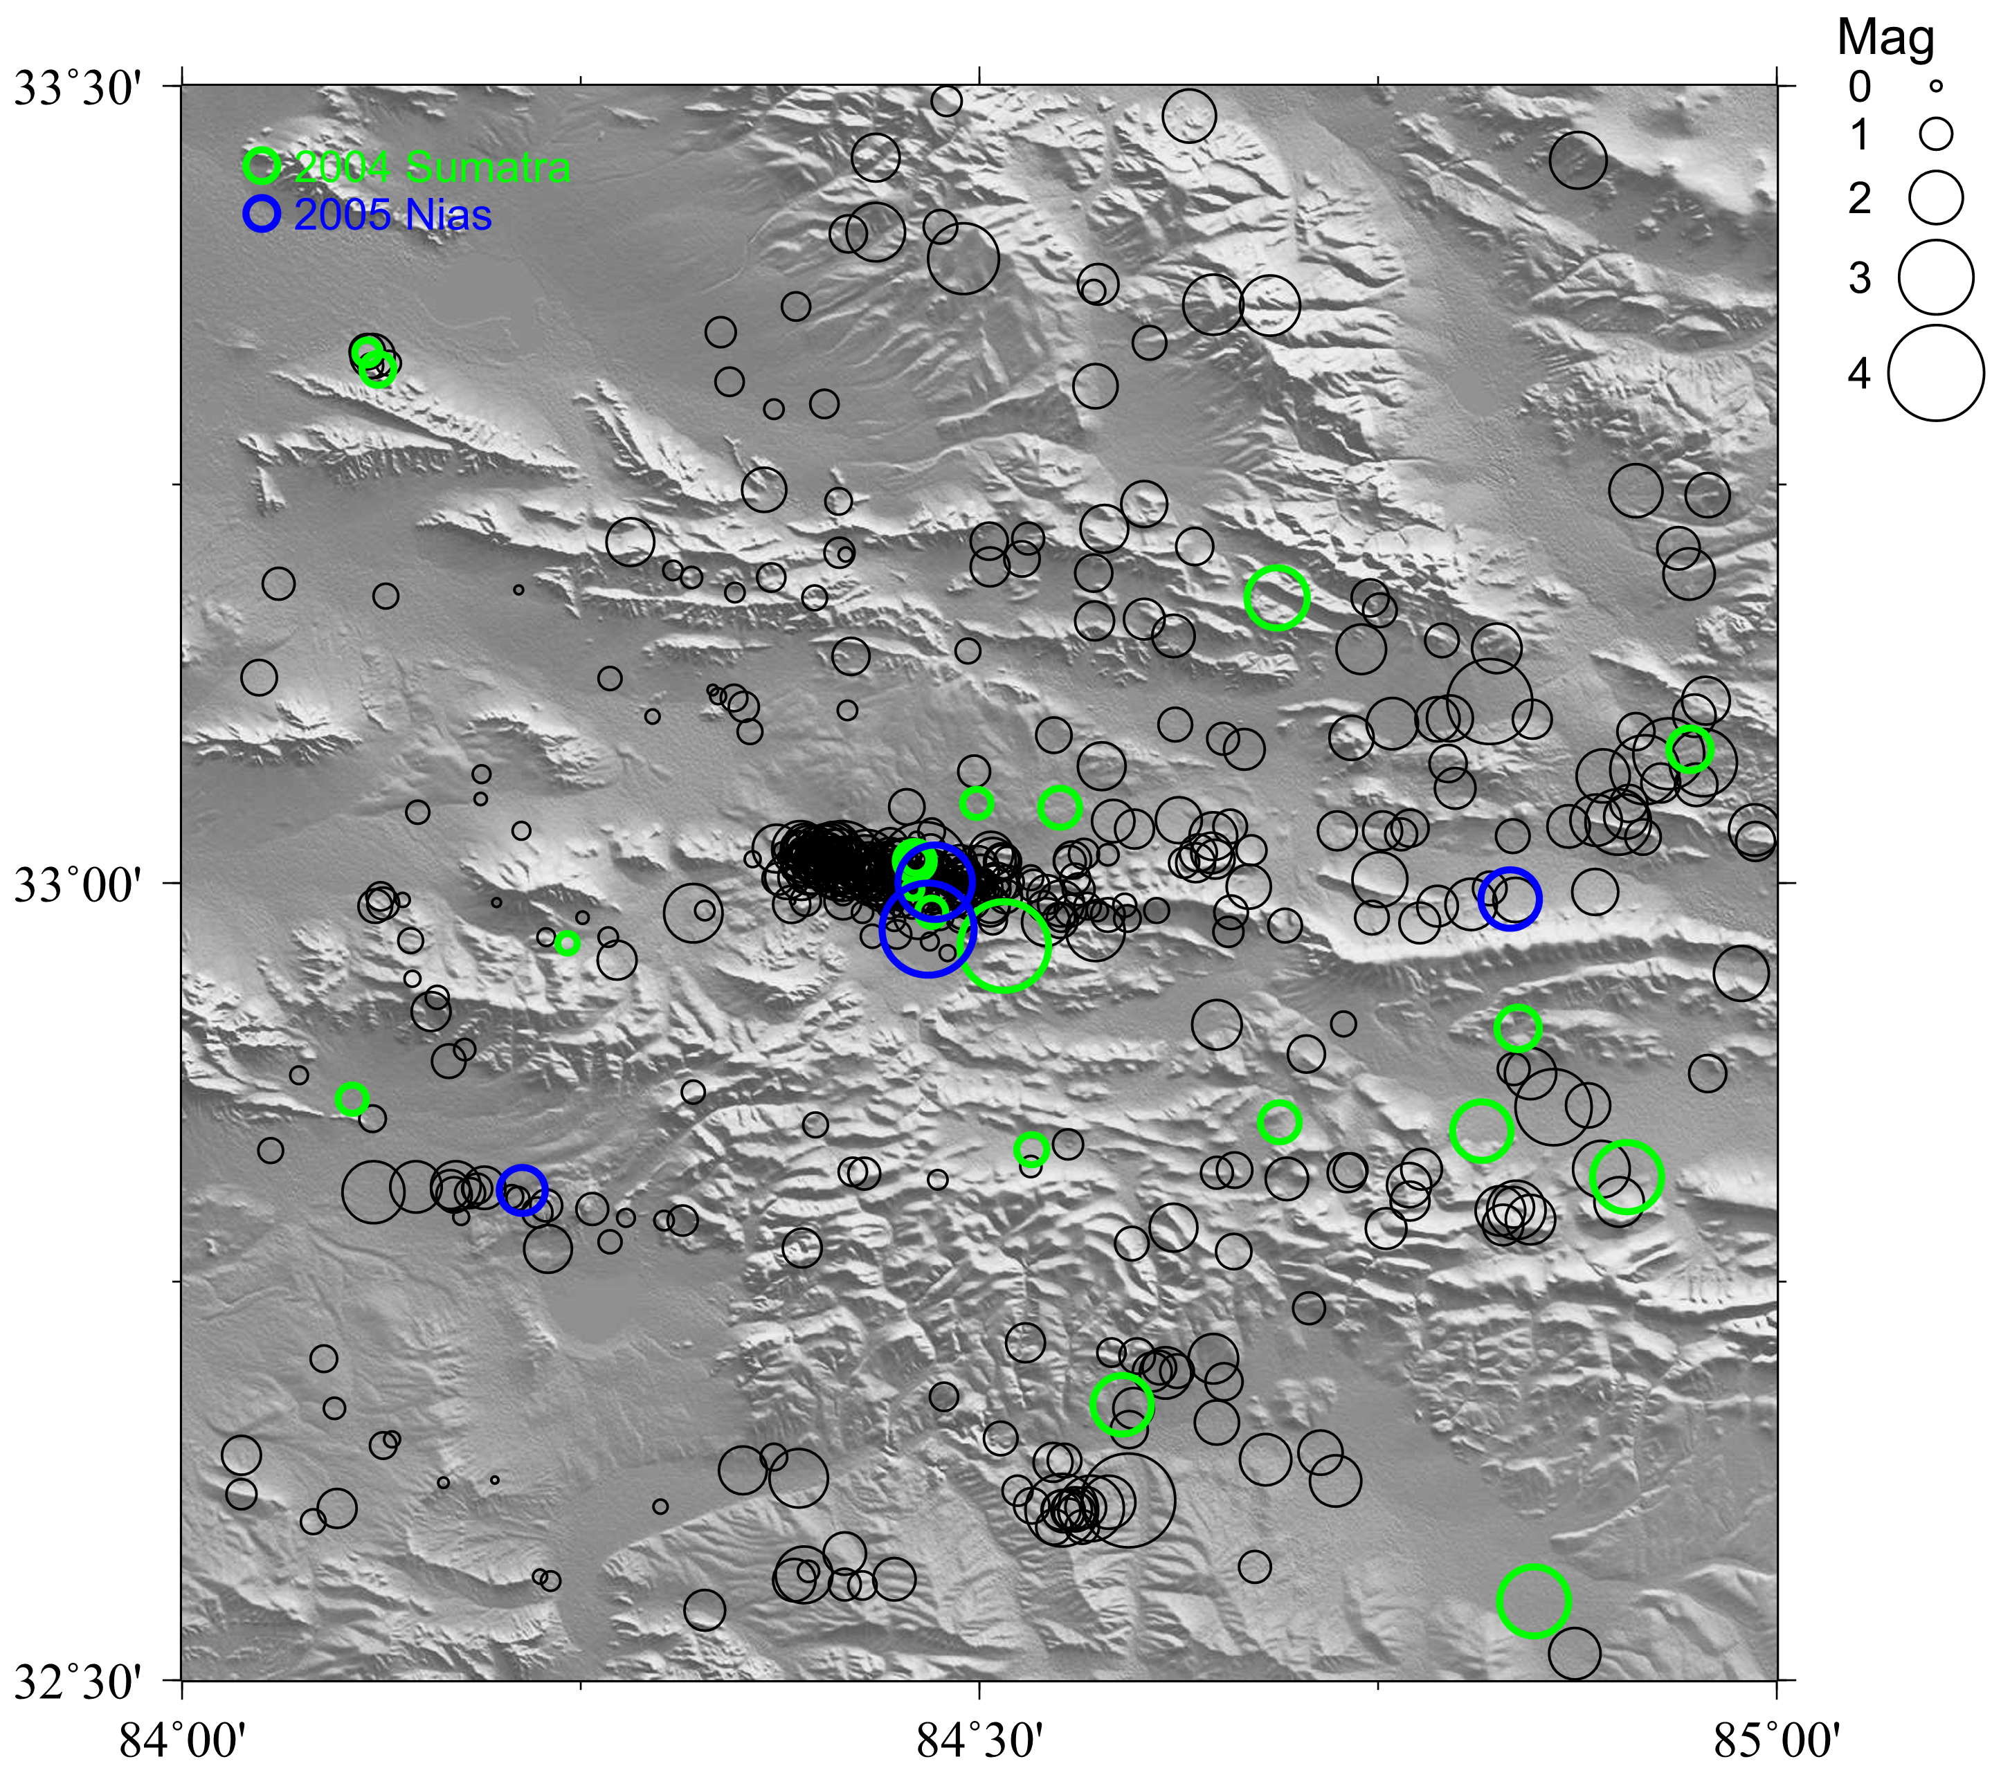

Figure 2. Spatial distribution of template events

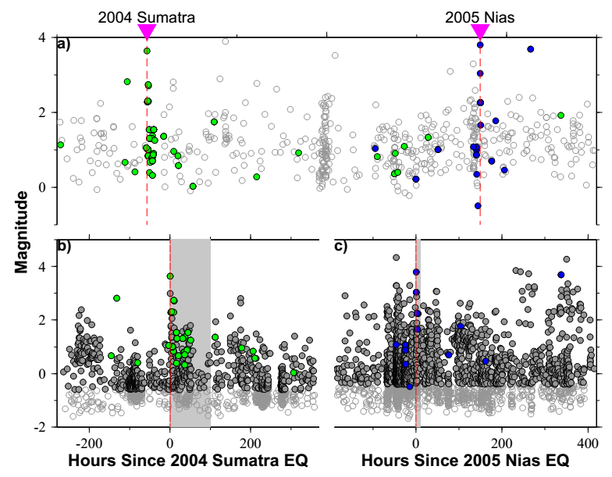

Figure 3. a) Catalog events using for detection. b) and c) are detection results around 2004 Sumatra and 2005 Nias (open/filled gray circles are all detections and selected events with magnitude higher than Mc), respectively. Shaded areas are windows using in Figure 5b and 5d. Green and blue filled circles are templates which detect events within the shaded area.

1. **It would also seem that the results don’t support the inference sometimes made that the potential to trigger correlates with the background rate, since the Zhongba ambient rate seems higher than that in the Gaize region?**

We try to explain the differences in triggering potential between Zhongba and Gaize by considering different aspects, i.e., geothermal, background seismicity rate, seismogenic depth. The heat flow map shows Lhasa Terrane has a higher value compared to Qiangtang Terrane (Tao & Shen 2008), which doesn’t support the observations that geothermal/volcanic regions with high heat flows favor triggering. The background rate could contribute to different triggering potential since it would help to estimate whether there are critical faults. We speculate that the 2004/07/11 Zhongba earthquake could release the accumulate the strain and made Zhongba away from the critical state when the 2004 Sumatra event occurred. This still couldn’t help to explain what happened after the 2005 Nias event (no observed triggered earthquakes, but followed the 2005 Mw 6.2 Zhongba earthquake). The network distribution restrict the detection for smaller events (i.e., <1), which could be the possible reason (with Mc 1.1 and 1.7 around 2004 Sumatra and 2005 Nias, respectively).

1. **The map of Figure 1b is so small it is hard to see the stations.  Perhaps it could be enlarged by showing only the region from 75 to 105 degrees E and 0 to 35 degrees N?**

Done. We updated the Figure 1b.

**Reviewer: 2  
Comments to the Author(s)**

1. **The authors do not state whether they employ their matched filter technique over a network of seismometers (Network Matched Filter technique) or over a single station or channel. From Figure 3, it appears they used a Network Matched filter, but this should be explicitly stated in the text. I make this point because single channel filters are still widely utilized, despite the fact that network filters far outperform single channel filters.**

Done. We employ our matched filter technique over a network of seismometers and I change them to Network Waveform Matched Filter Technique (NWMFT) in the main text.

1. **page 3; lines 41-48: You utilized windows of 12 seconds and 5 seconds for the template events, and offset the p-wave window (Z components) and s-wave windows (N,E components). First, this is a very small time window in my opinion. For example, Skoumal et al. (2014, EPSL) performed an analysis on template length for earthquakes in Ohio and found that a template length of 37 seconds produced the smallest number of false detections (though obviously Ohio and interior Asia have vastly different network geometries). Your figure 3 illustrates why longer templates may be benefitial. There is a significant amount of waveform outside of your template window which is obviously related to the earthquake, for example the shear waves arriving on the vertical channel. By not including this signal, the filter is not utilizing all available signal to correlate with. Including extra time, even if there is no signal being recorded, does not significantly affect the statistics (e.g., MAD) of the resulting filter. For example, including very small amplitude variations on the horizontal components before the shear wave wont affect the filter because zero's correlated with continuous data will not add or subtract to the resulting correlation value of the filter.**

**Secondly, I don't see a justification for offsetting the vertical and horizontal components. I think this is left over from analysis of low frequency earthquakes in Japan (which brought this technique into the mainstream), where (a) many events are arriving at closer to vertical incidence due to their great station coverage, and (b) where the shear waves are often the only visible phases due to the small nature of the events. Why not just include all of the available signal? The resultant signal to noise ratio should increase.**

**While I would like to see this reprocessed with longer template times, I do not feel it is strictly necessary to the quality of the results. I fully believe the analysis and interpretation is satisfactory in current form, but the authors might realize slight gains in catalog robustness by increasing the template durations. I do not think that re-processing with longer template times will change any of their key observations or interpretations, and so it might not be worth the computational time.**

We agree that longer time window would have some benefits, including suppressing background noise and enhance the detection quality. Indeed, we miss some signals from Figure 3, including valuable P wave signals on horizontal channels and S wave on vertical channel (which would have higher amplitude than P wave). The reason we offset the vertical and horizontal components partly due to the tradition for analyzing low frequency earthquakes. We think it’s also from the idea that P wave has clearer and higher amplitude in vertical channel while horizontal channels give better S waves. We also want to separate P and S wave detection, which could allow for more nearby events if we use the weak form (Shelly et al., 2007). In contrast, a large window contain both P and S waves would result in a constant P-S travel time difference, which would only suitable for closer events. Finally, it would significantly increase the computational cost if applying a longer time window.

We also conduct a test by using different time window. Specifically, we select 10 templates in Gaize region and cross correlate with continuous waveform from 2005/03/26 to 2005/03/30. Two different kinds of time window are used: 5s (1s before and 4s after P and S waves for vertical and horizontal channels, respectively) window; 20s (2s before and 18s after P waves for all channels) window. Figure 3 shows the results for different time windows: b) panel is the distribution of cross correlation coefficient (CCC) vs time relative to 2005 Nias mainshock. Clearly, the 20s window has an overall lower CCC while the detection results are similar; a) panel show the times of median absolute deviation (MAD) in both cases. 20s window has a higher value due to longer window would suppress the CCC and has a lower MAD.

From the test, we conclude that the longer window would result in lower CCC and higher MAD, but the overall results are similar with our current time window. Besides, it takes multiple times of computation. To summarize, it’s a tradeoff between computational cost and detection quality.

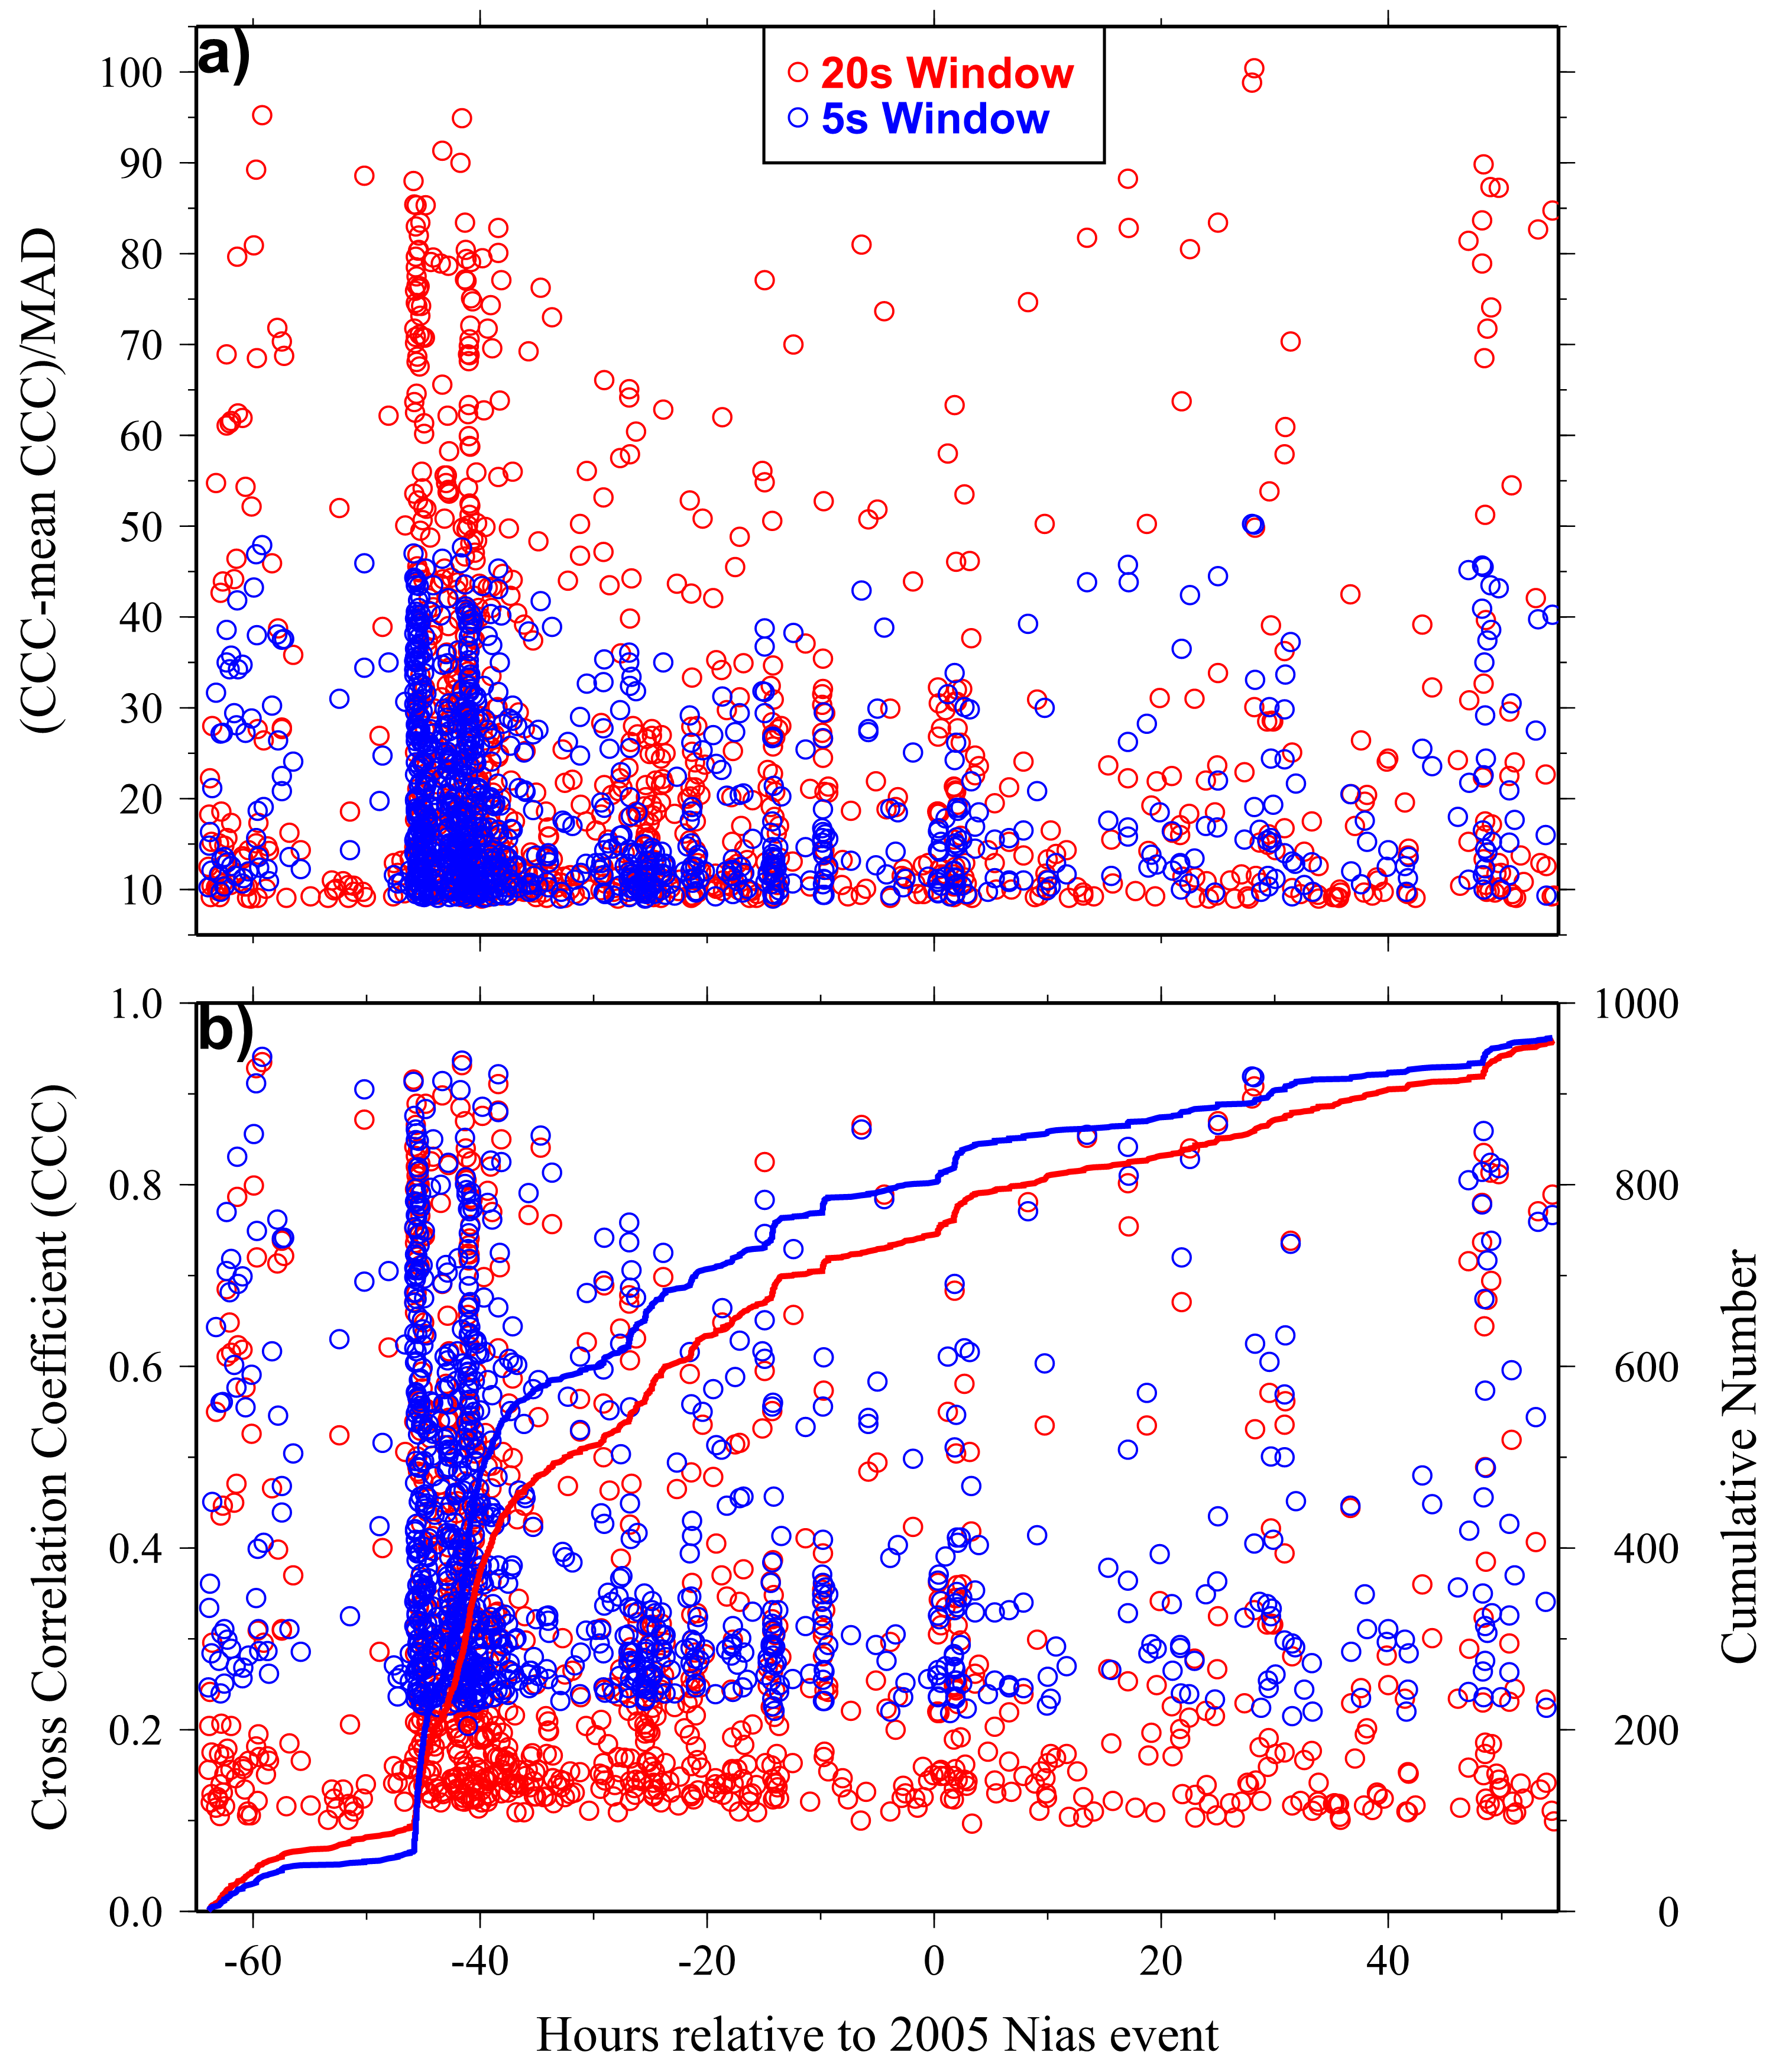

Figure 3. Comparison of detection results with different time window

1. **p 4;l 1-10: How did you combine the resulting catalogs? For example, if multiple of your template events are located very closely to each other and thus have similar waveforms, a new match could be detected from each of these templates. What steps did you take to ensure that your new total catalogs do not have multiple listings for the same earthquake?**

The way we remove duplicate detections is that we don’t allow any overlapping between two detections in the matched windows for all channels. Specifically, we find the matched time window for each detection, which is origin time plus P/S arrival as well as the selected window schema (1s before and 4s after, for instance). We compare the beginning/ending time of the windows and make sure they don’t have overlapping. This strong constrain could remove some real events but significantly help to eliminate duplicate detections.

1. **p4; l 26-29: I think it is important to note that your calculated magnitude of completeness (Mc) is not for the whole region, but only for the regions in the immediate vicinity of your template events. This distinction is also important when interpreting your b-value plots, for example in Figure S3. For example, the top-left, bottom-left, and bottom-right panels in Figure 3 shows a cumulative number of earthquakes that appear to have two shoulders in the distribution (another way to look at it is that your b-value fit line under-estimates the cumulative seismicity for about 1 magnitude level above Mc). Look at the bottom right panel in S3, for example. The first shoulder in cumulative seismisity looks like it's at about M2, with a linear region above this magnitude. This is probably the Mc of your initial hand-picked catalog. Then there is a region from M2 to M0 that is also linear, but at a shallower slope. I do not think this is real, but rather has to do with the fact that you're missing events that are far away from any template. In fact, you could calculate the expected number of “missed” events by taking the difference between the higher slope's intercept and the shallower slope's intercept. This curved cumulative seismicity plot could also be skewing your calculated Mc, as this calculation is based on when the distribution statistically deviates from linearity.**

We agree that the NWMFT still strongly rely on the distribution of templates and events far away from templates are still missing, which makes the calculated Mc is only for the regions in vicinity of all template events.

**Minor Points**

1. **p 1; l 3-4 and p 2; l 28: I prefer to use Network Matched Filter to distinguish this technique from the many single channel techniques currently utilized.**

Done. We change to NWMFT.

1. **p 1; l 40: This first sentence is awkward**

I changed “Earthquakes interact with each other within a wide range of space-time windows” to “Earthquakes can interact with each other in a wide range of spatial-temporal windows.”.

1. **p 1; l 47: change “critical” to “critically stressed”**

Done.

1. **Figure 1 should have a scale bar**

Done. We add a distance scale bar in Figure 1c.